CRICULAR VIAVATE

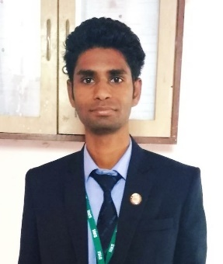

Name: DHARMENDRA DHAKD

Contact Details

Current Address: Personal Data

Room No.11 Sigma Hostel, Gender :- male

IIMS College, Nehre Marunji, DOB:-06-06-1992

Near Hinjewadi Infotech Park, E-mail :-dhakaddharmendra666@gmail.com

Pune-411033. Mobile No: 9179228459

Career Objective:-

I wish to evolve into a hardworking and sincere atmosphere, contributing to the success of the organization and at the same time enhance my knowledge and develop my communication, managerial and interpersonal skills and explore the opportunities in the field of Finance enabling me to make positive contribution towards growth of organization.

Professional Qualification:-

**PGDM -** Post Graduate Diploma in Management (AICTE Approved), from International Institute of Management Studies (IIMS Pune) Batch 2018-2020

**Major ---** Finance **Minor ---**Information Technology

**BCA-** Bachelor of Computer application in computer science

Academic Records:

|  |  |  |  |
| --- | --- | --- | --- |
| **Education** | **University/College Name** | **Year of Passing** | **Marks (%)** |
| BCA | MMYVV JABALPUR | 2014 | 62% |
| 12TH | MP BOARD | 2011 | 54% |
| 10TH | MP BOARD | 2009 | 40% |

Summer Internship programme

Name of the company:- Nirmal bang Securities Pvt. Ltd. Pune

Title of the project :- Analysis Of Mutual Fund through SIP

Project Profile :

* Trainee for studying Performance analysis of Mutual funds
* Sectorial analysis and performance in stock markets
* A study on Derivatives Segment

Social project:-

Organizing Education Fair in Villages

* Raising Funds For NGO’s
* Swachh Bharat Abhiyan

**Professional Certificate**

* Financial Modeling (Beginner)
* Currency Derivative (Beginner)
* Equity Research (Beginner)

Achievements & Honors:

* Currently working as the Member of Cultural Committee of International Institute of Management Studies, Pune.
* Worked as a Volunteer for Anchoring and Organizing committee for various CEO Conclaves in IIMS, Pune
* Successfully organized Independence day function with my team in IIMS, Pune
* Cultural event managed for college by our team.

Computer Proficiency:

**MS-Office:**

* MS-Excel (Intermediate)
* MS-Word (Intermediate)
* MS-PowerPoint (Intermediate)
* Language C, C++
* SAP
* TALLY

**Operating System:** WINDOWS

Hobbies:

* Book Reading(Fiction,Biography,Philosophy)
* Tracking
* Photography
* Dancing
* Travelling
* Playing Cricket

Declaration:-

I hereby declare that the information provided by me is true to the best of my knowledge and belief.

**Date:**

**Place**: Pune (Dharmendra dhakad)